Equipment Support - General

Validated Functional Job Description
August 2025

Reports To:
Positions Reporting To This Position:
Department:

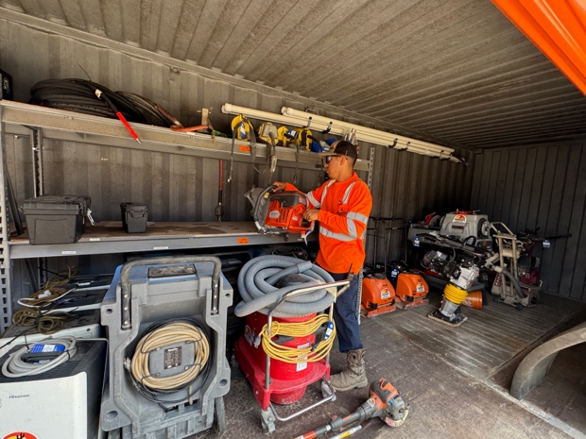
To Candidate:

This job description describes in detail the physical and envirofdfdnmental demands required to perform the essential duties of an Equipment Support - General. The physical demands of this job are classified as light-medium using U.S. Department of Labor criteria. It is important that you are physically able to perform this job safely. After reviewing this functional job description, please sign this document on the last page and indicate whether you believe that you can or cannot perform the essential duties of this job safely. If you believe that you have a disability which may cause a workplace limitation to performing any functional job duties, you should contact Human Resources.

I. General Job Description
Equipment Support – General; workers are responsible for staging and pulling various equipment for customer pick-ups. They maintain the yard, wash equipment and may assist with delivery as needed.

II. Essential Job Functions

Essential job functions are the fundamental duties of a job: the tasks and requirements that an employee holding the job absolutely must be able to do or comply with on the job. Essential job functions described in this document have been validated by on-site job analyses involving, job shadowing, direct measurements and employee and employer interviews. This functional job description may not be inclusive of all essential functions of the job as job demands and work conditions may vary. If an employee encounters a job demand that exceeds his /her safe ability to perform, the employee is required to seek assistance or request an accommodation from the employer. The employer will determine if any accommodations requested by an employee can be reasonably offered. The employer is not required to provide accommodations that create an undue hardship. The following information is a synopsis of key essential physical demand requirements of this job as determined by a detailed job analysis:

  - JOB ATTENDANCE: Employee must be available to work his/her assignment whenever he/she is scheduled to work. Regular and reliable job attendance is an essential function of the job.

  - STANDING / WALKING: Employee must have the ability to stand and walk for prolonged periods of time and be able to walk over even terrain with functional balance that does not require any special assistive devices.

  - SITTING: Employee must have the ability to sit for frequent periods of time when operating equipment.
  - AGILITY DEMANDS: Employee must be able to move the extremities and spine through a functional range of motion that will permit work to be safely performed from ground/floor level to full overhead level. Working in awkward postures to include flexing and twisting of the body, stooping, kneeling, and squatting while simultaneously reaching is required for this job.

  - COORDINATION/ POSITION SENSE/BALANCE: Employee must have general functional body and extremity coordination to handle materials and/or tools and sense of body position and balance when performing work tasks.

  - DEXTERITY DEMANDS: Employee must have good finger dexterity to manipulate small items and functional hand-eye coordination. Employee must be able to safely use one and two hands throughout the work period when handling tools and materials and when operating equipment.

  - GRIP STRENGTH DEMANDS: Employee must have adequate functional grip strength to use tools and safely lift and carry various parts and equipment throughout the work day (i.e., must be able to conduct these tasks without compensatory motions of the body that create unsafe stresses on the body). Employee must be able to functionally grip with adequate strength to safely lift/carry materials, hold onto railings of stairs and ladders while climbing.

  - CLIMBING: Employee must have adequate strength and coordination to safely climb on equipment, stairs, slanted ladders and vertical ladders (on/off equipment). Employee must be able to safely hold onto railings of stairs with one hand and the rungs of a ladder with two hands when climbing.

  - CARDIORESPIRATORY DEMANDS: Employee must have sufficient cardiorespiratory fitness to be able to perform physically demanding activities such as lifting, carrying, pushing, pulling, standing, walking, using tools and climbing stairs and vertical ladders (on/off equipment) with possible exposure to extremes in temperature.

09. MINIMUM ESSENTIAL PHYSICAL CAPACITIES REQUIRED FOR JOB PLACEMENT:
The essential functions for job placement are based on a job physical demands validation analyses. The essential functional abilities required to perform this job safely take into consideration mechanical and personnel assistance that can be reasonably offered or made available without adversely affecting job productivity standards and/or creating an undue hardship on the employer. The employer will consider accommodations for persons with covered disabilities.

A conditional job offer may be withdrawn when a person is unable to demonstrate sufficient physical abilities to perform the minimum essential functional demands of the job safely and/or poses an immediate threat of harm to self or other workers.

Based on a physical demand validation performed for this job by an independent ergonomic consultant, prior to job placement, an individual may be required to undergo a job-specific post-offer, pre-placement functional capacities examination to demonstrate that he/she can safely perform the following tests:

Lifting Abilities:
 Lift with 2 hands from floor to waist: 30 lbs x 4
 Lift with 2 hands from floor to shoulders: 30 lbs x 2
 Lift with 2 hands from floor to crown: 7 lbs x 2

Pushing and Pulling Abilities:
 Push horizontally with hands placed between waist and mid-chest level to generate a peak force of 30 lbs with two hands

 Pull horizontally with hands placed between waist and mid-chest level to generate a peak force of 30 lbs with two hands

Carrying Abilities:
 Carry with 2 hands at self-selected height: 30 lbs for a distance of 50 feet

Stair / Ladder Climbing Abilities:
 Stair Climb: Climb up and down a total of 24 steps
 Ladder climb Test: Climb up and down 8 rungs

Agilities:

 Stooping and Twisting: From standing, perform alternate toe touches x 3 to each side
 Kneeling: From standing, kneel on one knee, return to full standing and then kneel on opposite knee. Repeat kneeling test x 3, each knee
 Sustained Squatting: From standing, lower body into a functional squat position and hold posture for 30 seconds
 Repetitive Squatting: Repeat squats x 3 reps

Note: This functional job description may be reviewed and revised periodically as Company deems appropriate. The basis for the physical demand requirements are described in the sections of this functional job description that follow. Frequency of material handling may vary considerably depending on operational conditions. In certain situations the physical demands for certain jobs may actually exceed those listed above. However, the employee is expected to seek assistance if material handling requirements cannot be performed safely.

III. Essential Physical Activities

Activity: | O | F | C | N | Activity: | O | F | C | N
01. Standing |  |  |  |  | 14. Peripheral Vision
02. Walking |  |  |  |  | 15. Depth Perception
03. Sitting |  |  |  |  | 16. Color Vision
04. Stooping |  |  |  |  | 17. Hearing - Speech Range
05. Kneeling |  |  |  |  | 18. Reaching, High, Low, Level
06. Squatting |  |  |  |  | 19. Lifting
07. Body Twisting |  |  |  |  | 20. Carrying
08. Crawling |  |  |  |  | 21. Pushing
09. Sense of Touch |  |  |  |  | 22. Pulling
10. Manual Dexterity |  |  |  |  | 23. Climbing Ladders
11. Speaking Clearly |  |  |  |  | 24. Climbing Stairs
12. Seeing Distant |  |  |  |  | 25. Balancing
13. Seeing – Reading

FREQUENCY KEY:
O - Occasionally, less than 33% of work time
F - Frequently, 34 - 66% of the work time
C - Constantly, 67% - 100% of the time
N - Not a significant part of the job

IV. Special Comments Related to Essential Physical Activities

NA

V. Essential Environmental Requirements of the Job

The work environment characteristics described here are representative of those that the employee encounters while performing the essential functions of this job. The work environment could vary depending on the location of the job. For those jobs that are remote or isolated from immediate medical care, the environmental conditions are considered an essential function of the job. Additionally, for those jobs that are performed in extreme climates, the ability to safely perform the duties in those conditions is also considered an essential function of the job.
 | O | F | C | N
01. Extreme Cold - Below 30 º F Seasonal
02. Extreme Heat - Above 100 º F Seasonal
03. Dryness
04. Wetness
05. Humidity - Above 90%
06. Noise - Over 85 Decibels
07. Respirator - Breathing Apparatus
08. Confined/Cramped Spaces
09. Elevated Heights
10. Working Around/With People
11. Working Alone

FREQUENCY KEY:
O - Occasionally, less than 33% of work time
F - Frequently, 34 - 66% of the work time
C - Constantly, 67% - 100% of the time
N - Not a significant part of the job

VI. Airborne Contaminants & Chemicals in Work Environment

Potential exposures in the work environment include, but are not limited to: aromatic hydrocarbons, volatile organic carbons (VOC), combustion exhaust, welding fumes, natural gas cleaning agents, oils and dust.

The facility maintains an accessible chemical inventory and associated Safety Data Sheets that can be used to find more detailed hazard information.

VII. Validated Essential Material Handling Requirements

A. Lifting – Essential Requirements
Floor to Knuckle Level Lifts
Lifting Method | Weight/Force | Frequency | Materials / Tool / Procedure
One-Two Handed with assistance (3+) | 30 lbs each | Occasional | Electric Hammer  Total Wt: 97 lbs
One-Two Handed with assistance (2+) | 30 lbs each | Occasional | Fork Bar  Total Wt: 80 lbs
One-Two Handed with assistance (2+) | 30 lbs each | Occasional | Air Hammer  Total Wt: 71-77 lbs
One-Two Handed with assistance (2+) | 21-30 lbs each | Occasional | Propane Tanks  Total Wt: 21-71 lbs
One-Two Handed with assistance (2+) | 22-30 lbs each | Occasional | Auger Bits  Total Wt: 43-73 lbs
One-Two Handed with assistance. | 20-30 lbs each | Occasional | Manual Material Lift  Total Wt: 40-60 lbs
Two Handed | 29 lbs | Occasional | Drill Bits
One-Two Handed with assistance. | 26-28 lbs each | Occasional | Extension  Total Wt: 52-57 lbs
One-Two Handed | 23-28 lbs | Occasional | Hose
One-Two Handed with assistance. | 28 lbs each | Occasional | Roller Extension  Total Wt: 56 lbs
One-Two Handed | 25 lbs | Occasional | Rock Drill
One-Two Handed | 24 lbs | Occasional | Saw
One-Two Handed with assistance. | 23 lbs each | Occasional | Hose  Total Wt: 46 lbs
One-Two Handed with assistance. | 23 lbs each | Occasional | Case of Water  Total Wt: 45 lbs
One-Two Handed with assistance. | 18-19 lbs each | Occasional | Rivet Buster  Total Wt: 36-38 lbs
One-Two Handed with assistance. | 17 lbs each | Occasional | Sub Pump  Total Wt: 34 lbs
One-Two Handed | 15 lbs | Occasional | Pole Saw
One-Two Handed | 13 lbs | Occasional | Welding Plate
One-Two Handed | 7 lbs | Occasional | Air Hose
Floor to Waist Level Lifts
Lifting Methods | Weight/Force | Frequency | Materials / Tool / Procedure
One-Two Handed with assistance (3+) | 30 lbs each | Occasional | Electric Hammer  Total Wt: 97 lbs
One-Two Handed with assistance (2+) | 30 lbs each | Occasional | Fork Bar  Total Wt: 80 lbs
One-Two Handed with assistance (2+) | 30 lbs each | Occasional | Air Hammer  Total Wt: 71-77 lbs
One-Two Handed with assistance (2+) | 21-30 lbs each | Occasional | Propane Tanks  Total Wt: 21-71 lbs
One-Two Handed with assistance (2+) | 22-30 lbs each | Occasional | Auger Bits  Total Wt: 43-73 lbs
One-Two Handed with assistance. | 20-30 lbs each | Occasional | Manual Material Lift  Total Wt: 40-60 lbs
Two Handed | 29 lbs | Occasional | Drill Bits
One-Two Handed with assistance. | 26-28 lbs each | Occasional | Extension  Total Wt: 52-57 lbs
One-Two Handed | 23-28 lbs | Occasional | Hose
One-Two Handed with assistance. | 28 lbs each | Occasional | Roller Extension  Total Wt: 56 lbs
One-Two Handed | 25 lbs | Occasional | Rock Drill
One-Two Handed | 24 lbs | Occasional | Saw
One-Two Handed with assistance. | 23 lbs each | Occasional | Hose  Total Wt: 46 lbs
One-Two Handed with assistance. | 23 lbs each | Occasional | Case of Water  Total Wt: 45 lbs
One-Two Handed with assistance. | 18-19 lbs each | Occasional | Rivet Buster  Total Wt: 36-38 lbs
One-Two Handed with assistance. | 17 lbs each | Occasional | Sub Pump  Total Wt: 34 lbs
One-Two Handed | 15 lbs | Occasional | Pole Saw
One-Two Handed | 13 lbs | Occasional | Welding Plate
One-Two Handed | 7 lbs | Occasional | Air Hose
Floor to Shoulder Level Lifts
Lifting Methods | Weight/Force | Frequency | Materials / Tool / Procedure
One-Two Handed with assistance (2+) | 21-30 lbs each | Occasional | Propane Tanks  Total Wt: 21-71 lbs
One-Two Handed with assistance. | 23 lbs each | Occasional | Case of Water  Total Wt: 45 lbs
One-Two Handed with assistance. | 18-19 lbs each | Occasional | Rivet Buster  Total Wt: 36-38 lbs
One-Two Handed | 15 lbs | Occasional | Pole Saw
One-Two Handed | 7 lbs | Occasional | Air Hose
Floor to Crown Level Lifts
Lifting Methods | Weight/Force | Frequency | Materials / Tool / Procedure
One-Two Handed | 7 lbs | Occasional | Air Hose

B. Carrying
Method | Weight | Coupling | Distance | Frequency | Material / Tool
One-Two Handed with assistance (3+) | 30 lbs each | Good | 50 ft | Occasional | Electric Hammer  Total Wt: 97 lbs
One-Two Handed with assistance (2+) | 30 lbs each | Good | 50 ft | Occasional | Fork Bar  Total Wt: 80 lbs
One-Two Handed with assistance (2+) | 30 lbs each | Good | 10 ft | Occasional | Air Hammer  Total Wt: 71-77 lbs
One-Two Handed with assistance (2+) | 21-30 lbs each | Good | 50 ft | Occasional | Propane Tanks  Total Wt: 21-71 lbs
One-Two Handed with assistance (2+) | 22-30 lbs each | Fair | 10 ft | Occasional | Auger Bits  Total Wt: 43-73 lbs
One-Two Handed with assistance. | 20-30 lbs each | Good | 50 ft | Occasional | Manual Material Lift  Total Wt: 40-60 lbs
Two Handed | 29 lbs | Fair | 10 ft | Occasional | Drill Bits
One-Two Handed with assistance. | 26-28 lbs each | Good | 10 ft | Occasional | Extension  Total Wt: 52-57 lbs
One-Two Handed | 23-28 lbs | Poor | 50 ft | Occasional | Hose
One-Two Handed with assistance. | 28 lbs each | Good | 10 ft | Occasional | Roller Extension  Total Wt: 56 lbs
One-Two Handed | 25 lbs | Good | 10 ft | Occasional | Rock Drill
One-Two Handed | 24 lbs | Fair | 10 ft | Occasional | Saw
One-Two Handed with assistance. | 23 lbs each | Poor | 10 ft | Occasional | Hose  Total Wt: 46 lbs
One-Two Handed with assistance. | 23 lbs each | Poor | 25 ft | Occasional | Case of Water  Total Wt: 45 lbs
One-Two Handed with assistance. | 18-19 lbs each | Good | 10 ft | Occasional | Rivet Buster  Total Wt: 36-38 lbs
One-Two Handed with assistance. | 17 lbs each | Fair | 10 ft | Occasional | Sub Pump  Total Wt: 34 lbs
One-Two Handed | 15 lbs | Good | 10 ft | Occasional | Pole Saw
One-Two Handed | 13 lbs | Fair | 10 ft | Occasional | Welding Plate
One-Two Handed | 7 lbs | Poor | 10 ft | Occasional | Air Hose

C. Pushing / Pulling - Peak Forces
Push Force | Pull Force | Frequency | Hand Position | Material/Tool:
20-60 lbs | 20-60 lbs | Occasional | Waist | Pallet Jacks/Material Lift
20-30 lbs | 20-30 lbs | Occasional | Floor-Crown | Connex Doors

D. Stair Climbing
Flights Per Day | Average Steps per Flight | Frequency
1 | 24 | Occasional

C. Ladder Climbing
Ladder Height | Average Number of Rungs | Frequency | Slanted or Vertical
4’ | 2-5 | Occasional-Frequent | Climbing on/off Equipment

FREQUENCY KEY:
O - Occasionally, less than 33% of work time
F - Frequently, 34 - 66% of the work time
C - Constantly, 67% - 100% of the time
N - Not a significant part of the job

VIII. Physical Demand Level (PDL) Description

FREQUENCY | Sedentary | Sed-Light | Light | Light-Med | Medium | Med-Heavy | Heavy | Very Heavy
O - Occasional  1 - 33% | 10 lbs | 15 lbs | 20 lbs | 35 lbs | 50 lbs | 75 lbs | 100 lbs | > 100 lbs
F- Frequent  34 - 66% | ----- | 7 lbs | 10 lbs | 17 lbs | 25 lbs | 37 lbs | 50 lbs | > 50 lbs
C – Constant  67% + | ----- | ----- | ------ | 5 lbs | 10 lbs | 15 lbs | 20 lbs | > 20 lbs
 | Sit | Sit/  Stand | Stand/Walk | Stand/Walk | Stand/  Walk | Stand/  Walk | Stand/Walk | Stand/  Walk

IX. Physical Demand Level Classification

Employees identified in this document must be able to safely perform up to light-medium physical labor as classified by the United States Departments of Labor. Physical demands typically involve walking, bending, reaching, climbing, lifting, carrying, pushing, and pulling.

X. Cardiorespiratory Demands

Employee must have sufficient cardiorespiratory fitness to perform the essential functions of this job safely. Employee must be able to safely tolerate light-medium demands on the cardiorespiratory system related to material handling and constant standing and frequent walking.

XI. Energy Expenditure

Employee must have an aerobic capacity sufficient for energy expenditure of 2.2-5.5 METS which is consistent with a PDL classification of light-medium as classified by the United States Department of Labor.

PDL: | HEART RATE: | ENERGY EXPENDITURE
SEDENTARY | 70 – 80 | 1.5-2.1 METS
LIGHT | 81 – 90 | 2.2-3.5 METS
MEDIUM | 91 – 110 | 3.6-5.5 METS
HEAVY | 111- 130 | 5.6-7.5 METS
VERY HEAVY | Over 130 | Over 7.5 METS

METS - Job demands can be expressed in METS, or metabolic equivalents, related to a person’s resting oxygen usage, and compared to the worker’s performance on a comparable aerobic capacity test.

XII. Validated Materials Handled and Weights (Lbs)

Material weights and handling forces have been accurately measured and determined to be representative of the type of materials and forces required to perform the essential duties of work performed by employees identified in this document. The primary physical demands observed and measured during this analysis included lifting, carrying, pushing, and pulling.

No. | Description | Weight in Lbs / Force in F-Lbs
 | Air Hammer | 71-77 lbs
 | Air Hose | 7 lbs
 | Auger Bits | 43-73 lbs
 | Case of Water | 45 lbs
 | Drill Bits | 29 lbs
 | Electric Hammer | 97 lbs
 | Extension | 52-57 lbs
 | Fork Bar | 80 lbs
 | Hose | 23-28 lbs
 | Hose | 46 lbs
 | Manual Material Lift | 40-60 lbs
 | Pole Saw | 15 lbs
 | Propane Tanks | 21-71 lbs
 | Rivet Buster | 36-38 lbs
 | Rock Drill | 25 lbs
 | Roller Extension | 56 lbs
 | Saw | 24 lbs
 | Sub Pump | 34 lbs
 | Welding Plate | 13 lbs
 | Push/Pull: Connex Doors | 20-30 F-lbs
 | Push/Pull: Pallet Jacks/Material Lifts | 20-45 F-lbs

XIII. Special Requirements

1. Must be able to wear necessary PPE as per task assigned.
2. Must be able to work in extreme temperatures (hot or cold).

XIV. Guidelines for Physical Demand Validation (PDV) Analysis

Physical demand validation analysis was performed based on guidelines established by the United States Department of Labor (USDL) and the Occupational Safety and Health Administration (OSHA). Validation of physical demands of job tasks is required for developing an accurate and valid functional job description as required by guidelines consistent with the Americans with Disabilities Act (ADA) and EEOC regulations for fair hiring practices. The physical demands described in this functional job description represent typical physical demand requirements of job tasks analyzed. Physical demands may at times exceed those identified in this report. Employees are required to adhere to all safety guidelines established by the employer and seek assistance to perform any task which they may feel exceeds their safe capacities to perform.

XV. Methods of PDV Analysis

- Personal interview, questionnaires, and on-site direct observation of job activities.
2. Measurements of material handling forces using push-pull dynamometers and weight scales.
3. Measurements of material dimensions, distances, heights, and reaches using tape measures.
4. Photography

Physical demand validation analysis was performed under the direction of Trevor Bardarson PT, OCS, CBES & Richard W. Bunch. Ph.D., P.T., C.B.E.S., WorkSaver Employee Testing Systems, LLC.

XVI. Photographic Records:

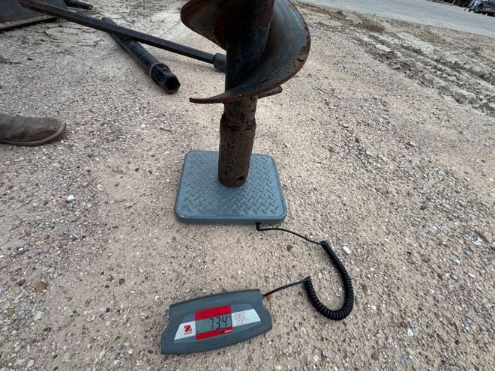 | 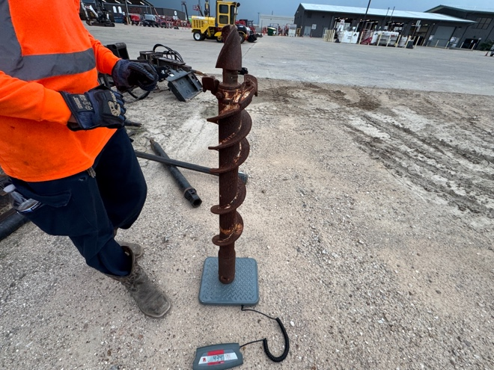
Must be able to lift/carry with assistance drill bits weighing 43-73 lbs.
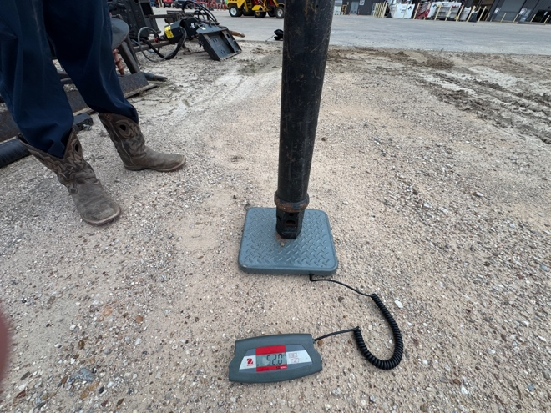 | 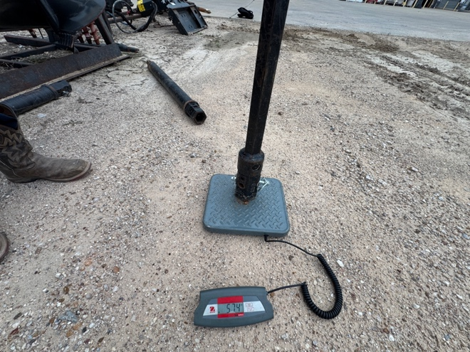
Must be able to lift/carry with assistance extensions weighing 52-57 lbs.
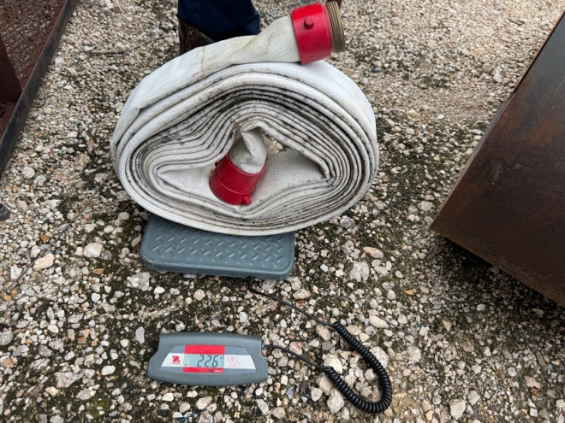 | 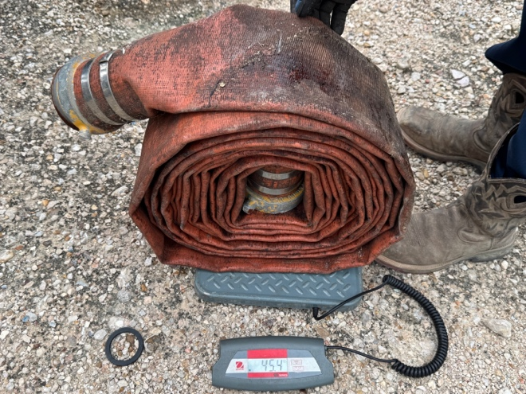
Must be able to lift/carry with assistance hose weighing 23-46 lbs.
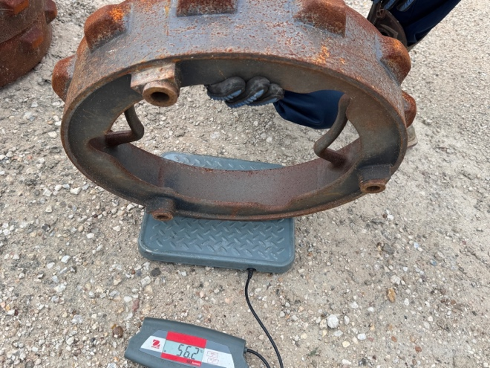 | 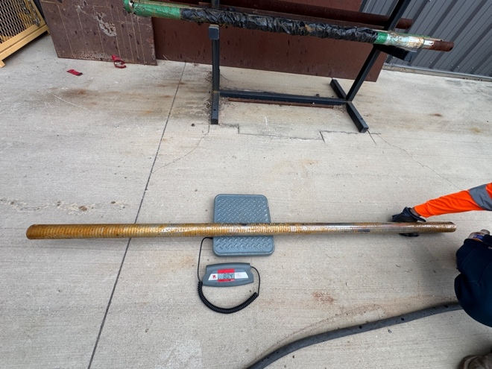
Must be able to lift/carry with assistance roller extensions weighing 56 lbs. | Must be able to lift/carry with assistance fork bars weighing 80 lbs.
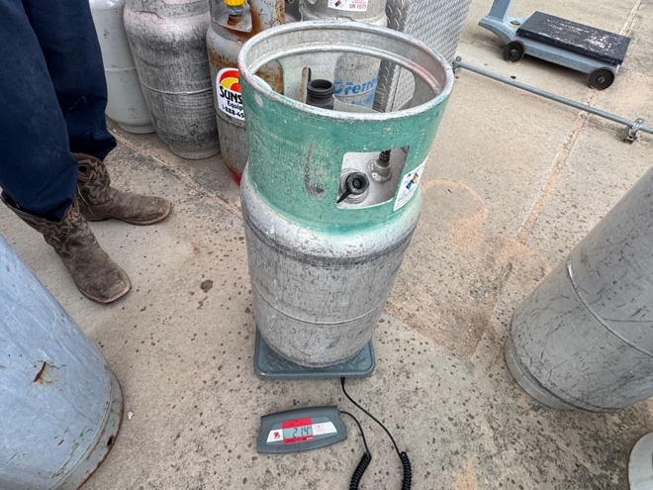 | 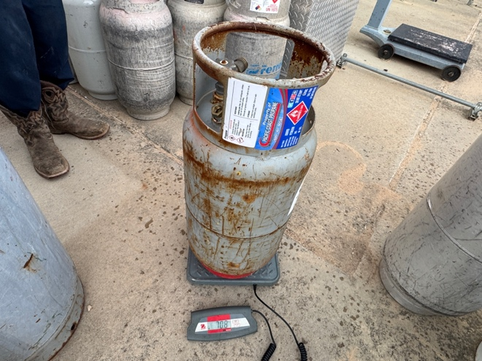
Must be able to lift/carry with assistance propane tanks weighing 21-71 lbs.
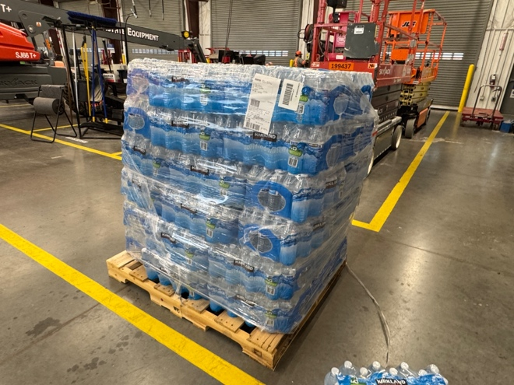 | 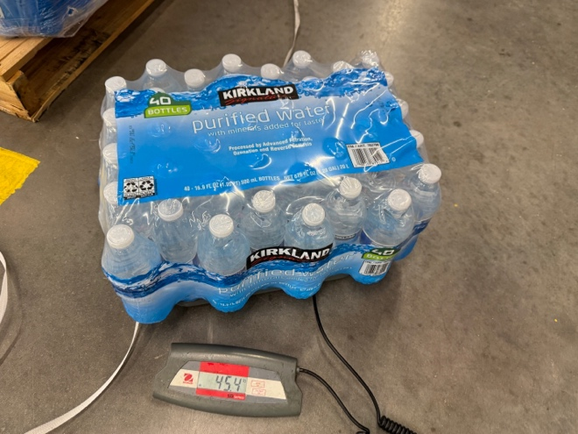
Must be able to lift/carry with assistance cases of water weighing 45 lbs.
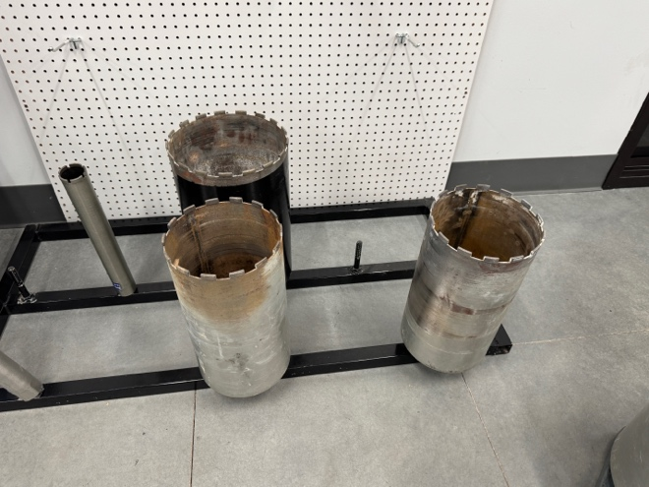 | 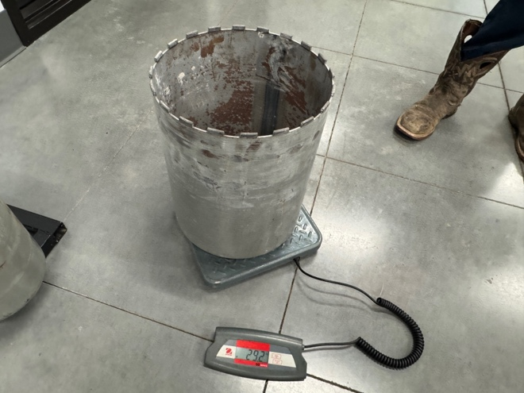
Must be able to lift/carry drill bits weighing 29 lbs.
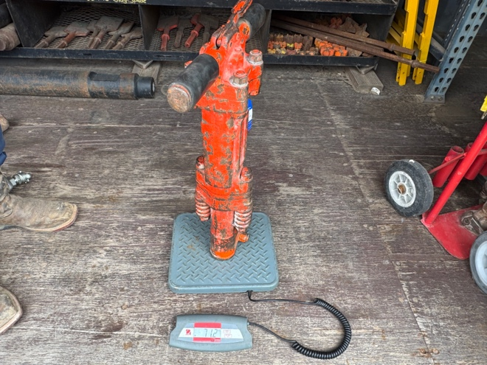 | 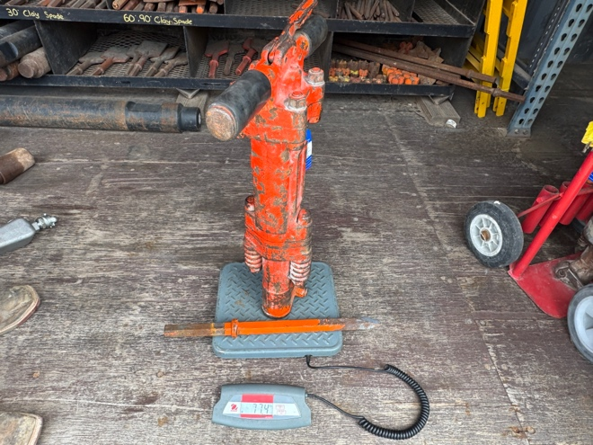
Must be able to lift/carry air hammers weighing 71-77 lbs.
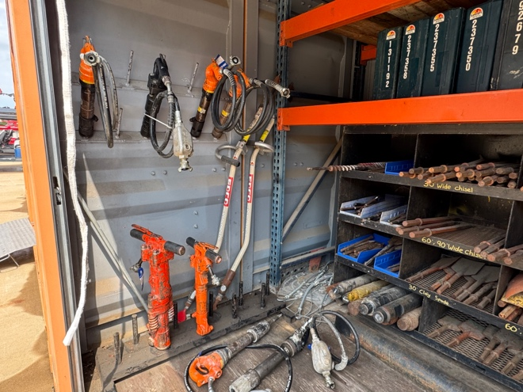 | 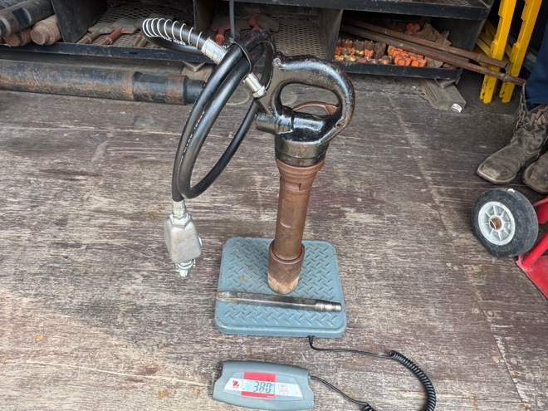
Must be able to lift/carry rivet busters weighing 36-38 lbs.
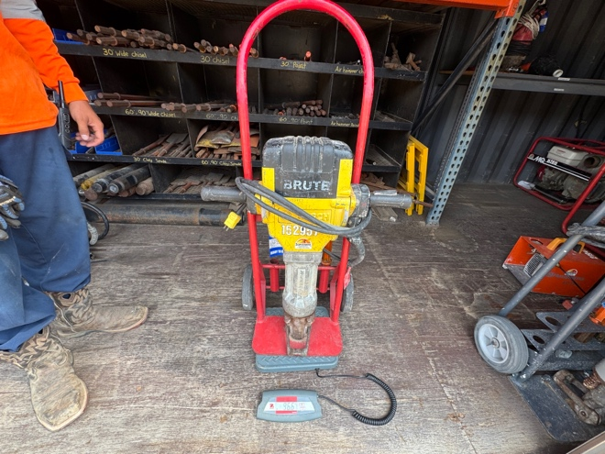 | 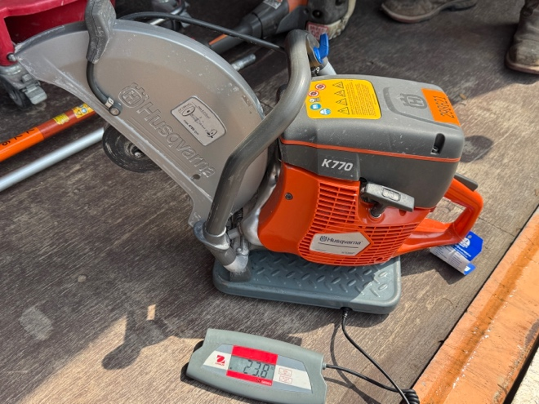
Must be able to lift/carry with assistance electric hammers weighing 97 lbs. | Must be able to lift/carry saws weighing 25 lbs.
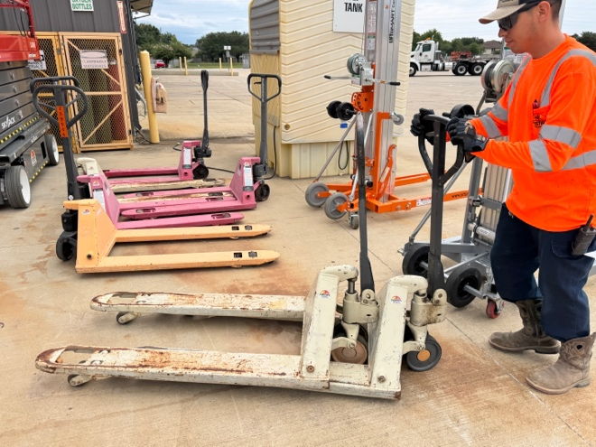 | 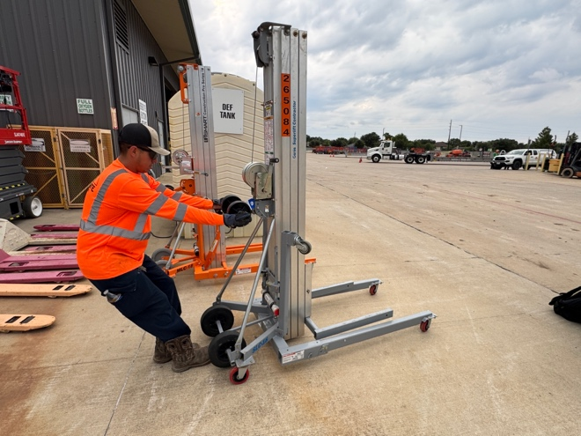
Must be able to push/pull pallet jacks and material lifts requiring 20-60 F-lbs.
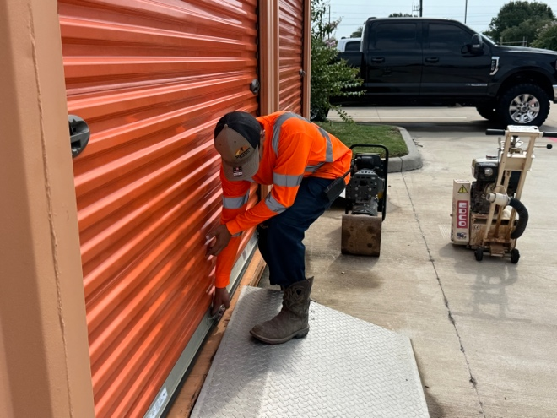 | 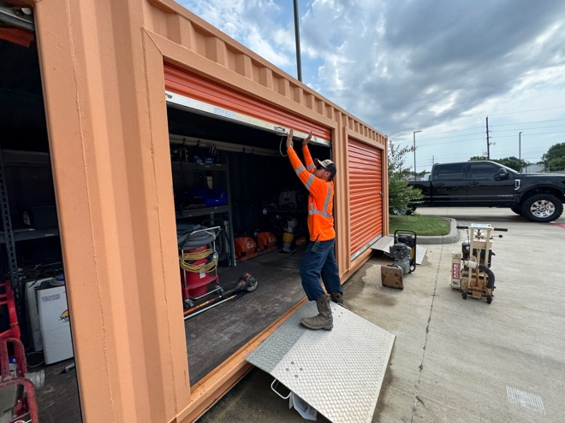
Must be able to push/pull connex doors requiring 20-30 F-lbs.
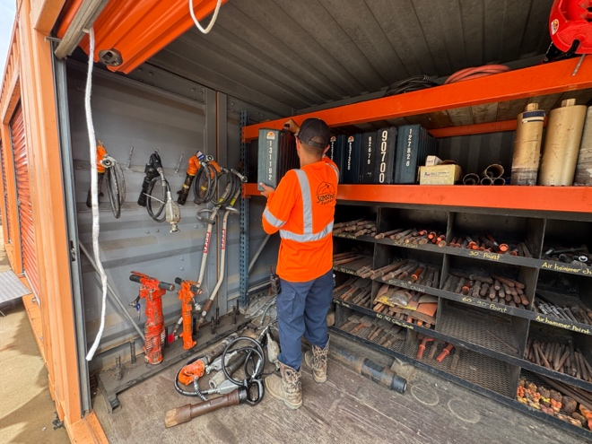 | 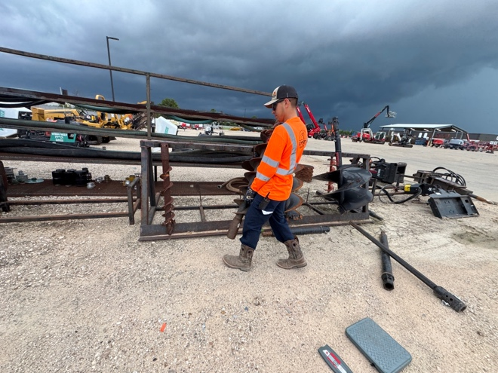
Must be able to constantly stand/walk throughout the workday.
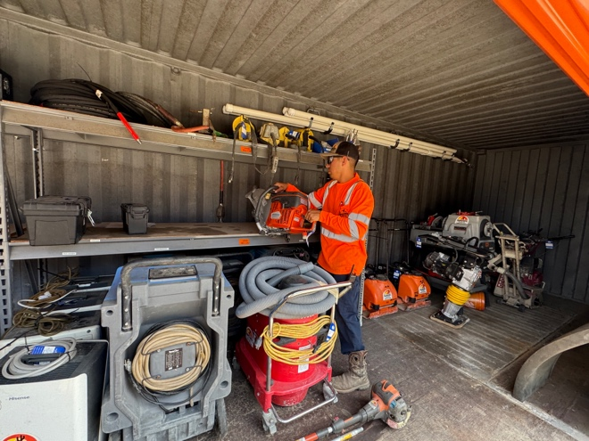 | 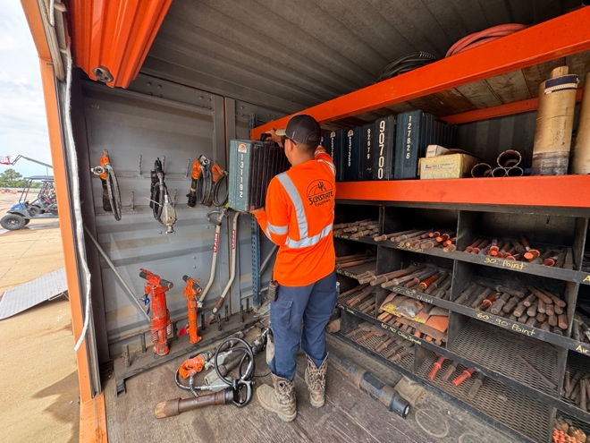
Must be able to constantly use their hands throughout the workday.
 | 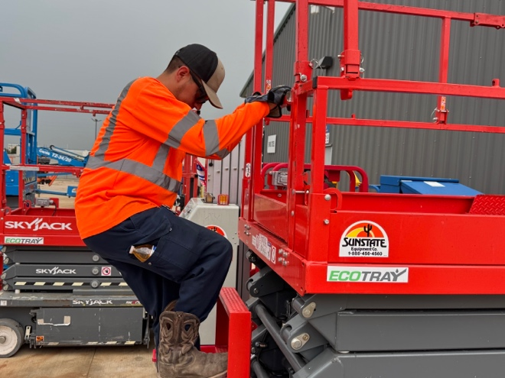
Must be able to constantly use their hands throughout the workday.
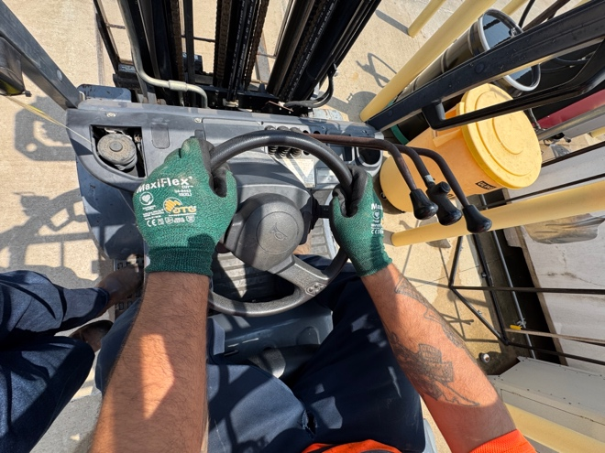 | 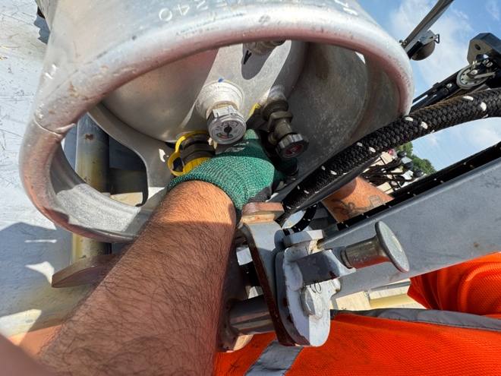
Must be able to constantly use their hands throughout the workday.
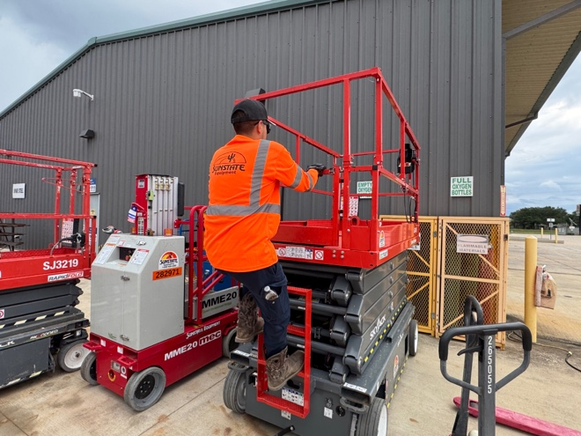 | 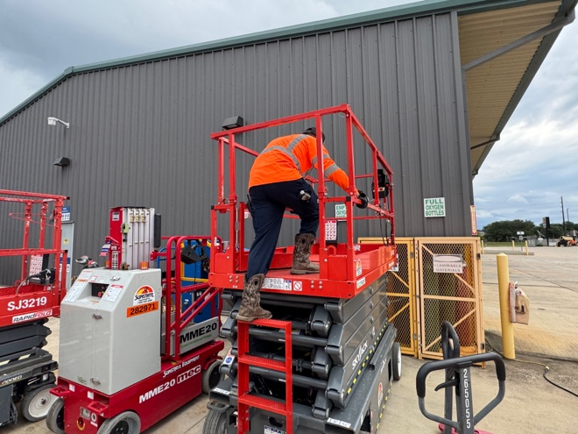
Must be able to climb on/off equipment throughout the workday.
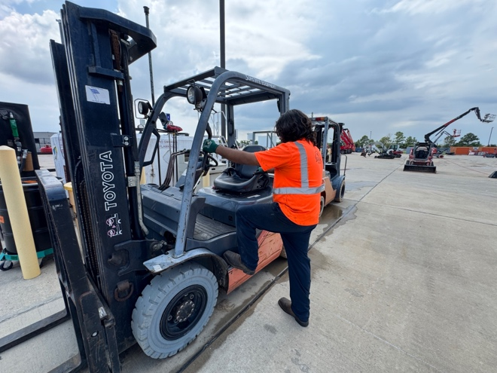 | 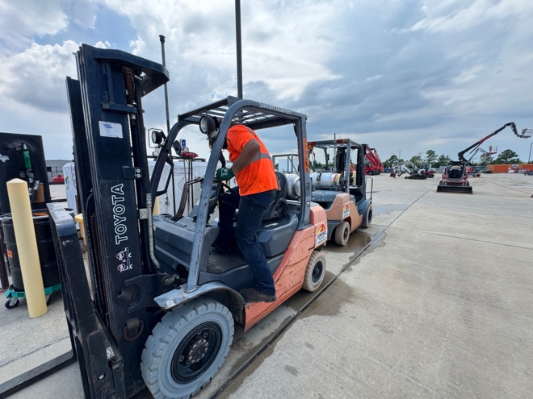
Must be able to climb on/off equipment throughout the workday.
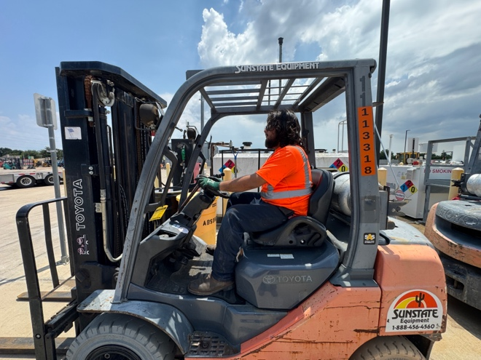 | 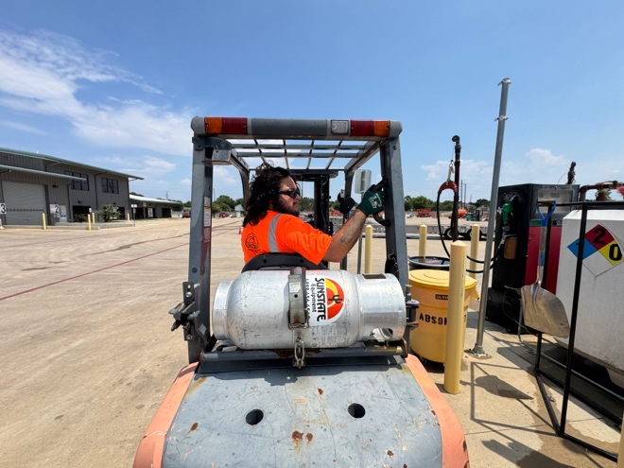
Must be able to sit and operate equipment throughout the workday. | Must be able to look behind when operating equipment.

FOR CANDIDATE:

Once you have completed reading the entire job description, please read and sign off on the appropriate response below:

_____ I believe I am capable of safely performing the essential duties of this position.

_____ I do not believe that I am capable of safely performing the essential duties of this position.

Note: If you believe that you have a disability which may cause a workplace limitation to performing any functional job duties, please inform Human Resources. Reasonable work accommodations may or may not be available. Employers are not required to provide work accommodations that create an undue hardship.

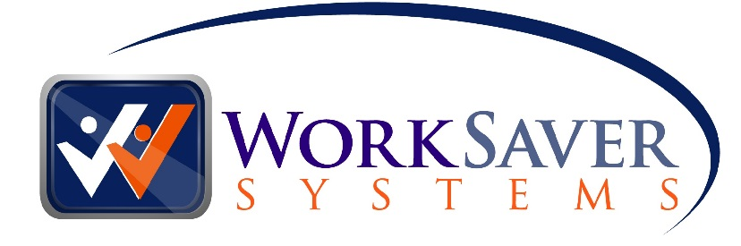
________________________
Printed Name

________________________
Signature

___________
Date

Subject Matter Expert Review
By my signature below I warrant, based on my work experience and detailed personal knowledge of the job described in this functional job description, that the information in this document accurately reflects the essential functions of this job:

1. _________________ ____________________ ____________________
Printed Name Job Title Years in Position

_________________ ____________________ ___/___/____ _______
Telephone Number Signature Date of Review Gender

2. _________________ ____________________ ____________________
Printed Name Job Title Years in Position

_________________ ____________________ ___/___/____ _______
Telephone Number Signature Date of Review Gender

3. _________________ ____________________ ____________________
Printed Name Job Title Years in Position

_________________ ____________________ ___/___/____ _______
Telephone Number Signature Date of Review Gender

4. _________________ ____________________ ____________________ _
Printed Name Job Title Years in Position

_________________ ____________________ ___/___/____ _______
Telephone Number Signature Date of Review Gender

5. _________________ ____________________ ____________________
Printed Name Job Title Years in Position

_________________ ____________________ ___/___/____ _______
Telephone Number Signature Date of Review Gender

6. _________________ ____________________ ____________________ _
Printed Name Job Title Years in Position

_________________ ____________________ ___/___/____ _______
Telephone Number Signature Date of Review Gender

7. _________________ ____________________ ____________________ _
Printed Name Job Title Years in Position

_________________ ____________________ ___/___/____ _______
Telephone Number Signature Date of Review Gender

